**INDIRA GANDHI UNIVERSITY MEERPUR REWARI**

**DEPARTMENT OF**

**COMPUTER SCIENCE & ENGINEERING**

**Certificate of Completion**

This is to certify that the minor project entitled **“Web Code Editor”** carried out by **Mr. Himanshu**, student of **BACHELOR OF TECHNOLOGY IN COMPUTER SCIENCE AND ENGINEERING 6th SEM**, **of Indira Gandhi University, Meerpur, Rewari** is a satisfactory account of the bonafide work under my supervision, is recommended towards the end of his/her 6th semester of B.Tech(CSE).

**Dr. Savita Sheoran Mrs. Pooja Mam**

**Chairperson, CSE Project Incharge**

**DECLARATION BY THE TEAM**

We, **Mr. Himanshu, Mr. Shivam Sharma and Mr. Chankit Yadav,** hereby declare that the minor project work entitled **“Web Code Editor”** is an authenticated work carried out by our team at **Indira Gandhi University, Meerpur, Rewari** for the partial fulfillment of the award of the degree of **B.Tech** and this work has not been submitted for similar purpose anywhere else.

**Date:20/05/2023 Himanshu Chankit Yadav Shivam Sharma**

**200011015021 200011015030 200011015023**

**ACKNOWLEDGEMENT**

I am really grateful to **Dr. Savita Sheoran**, Associate Professor & Chairperson, Department of CSE INDIRA GANDHI UNIVERSITY. Her infinite patience, continual encouragement, constant and energetic supervision, valuable advice, reading many inferior draft and correcting them at all stage have made it possible to complete this project documentation.

I would like to express my heartiest gratitude **to Mrs. Pooja**, Assistant Professor in Department of CSE, for his kind help to finish our project and also to other faculty member and the staff of CSE department of INDIRA GANDHI UNIVERSITY.

I would like to thank our entire course mate in Indira Gandhi University, who took part in this discuss while completing the course work.

I must also acknowledge with due respect the constant support and patients of my parents and friends.

Finally, the successful completion of this report would not have been possible without the support and assistance of many individuals and organizations. I would like to take this opportunity to offer my earnest admiration to each and every one of them.

**Mr. Himanshu**

**B.Tech 6th sem**

**Project Title: Web Code Editor**

**Table of Contents:**

1. **Introduction**
   1. Background
   2. Purpose of the Project
   3. Objectives
   4. Scope
   5. Methodology
2. **Overview of Code Editors**
   1. Definition and Importance
   2. Types of Code Editors
   3. Popular Code Editors in the Market
3. **Requirements Gathering**
   1. Functional Requirements
   2. Non-Functional Requirements
4. **Design and Architecture**
   1. System Architecture
   2. User Interface Design
   3. Data Structures and Algorithms
   4. Security Considerations
5. Implementation
   1. Technologies and Tools Used
   2. HTML Code Editor Implementation
   3. CSS Code Editor Implementation
   4. JavaScript Code Editor Implementation

6.The Project

7.HTML

8.CSS

9.Js

10.Real Time Example

11.Conclusion

* 1. Project Summary
  2. Achievements
  3. Lessons Learned
  4. Future Enhancements

12.References

1. **Introduction**
   1. **Background**

The introduction section provides an overview of the project's background, highlighting the need for a code editor specifically designed for HTML, CSS, and JavaScript.

* 1. **Purpose of the Project**

This section outlines the purpose of the project, explaining how the code editor aims to simplify the development process, improve productivity, and enhance code quality.

* 1. **Objectives**

The objectives of the project are defined, focusing on key goals such as providing syntax highlighting, code suggestions, and error detection for HTML, CSS, and JavaScript.

* 1. **Scope**

The scope of the project is outlined, specifying the features and functionalities that will be included in the code editor.

* 1. **Methodology**

The methodology used for the development of the code editor is described, including the agile development approach and the tools employed for project management.

1. **Overview of Code Editors**
   1. **Definition and Importance**

This section provides a comprehensive definition of code editors and explains their significance in the software development process.

* 1. **Types of Code Editors**

Different types of code editors, such as text editors, integrated development environments (IDEs), and online code editors, are discussed, along with their features and benefits.

* 1. **Popular Code Editors in the Market**

An overview of popular code editors available in the market, such as Visual Studio Code, Sublime Text, and Atom, is provided, highlighting their strengths and weaknesses.

1. **Requirements Gathering**
   1. **Functional Requirements**

Detailed functional requirements for the code editor are listed, covering features like syntax highlighting, auto-completion, code formatting, and code analysis.

* 1. **Non-Functional Requirements**

Non-functional requirements, including performance, usability, scalability, and security, are identified and described in this section.

1. **Design and Architecture**
   1. **System Architecture**

The overall architecture of the code editor is illustrated, explaining the various components, their interactions, and the data flow.

* 1. **User Interface Design**

The user interface design of the code editor is presented, showcasing the layout, menus, toolbars, and other user interaction elements.

* 1. **Data Structures and Algorithms**

The data structures and algorithms used in the code editor's implementation are described, focusing on efficient code parsing, indexing, and searching.

* 1. **Security Considerations**

The security measures implemented in the code editor, such as input validation, code sanitization, and access control, are discussed to ensure the protection of user data and prevent malicious code execution.

1. **Implementation**
   1. **Technologies and Tools Used**

The technologies and tools chosen for the implementation of the code editor, including programming languages, frameworks, and libraries, are listed and explained.

* 1. **HTML Code Editor Implementation**

The implementation details of the HTML code editor module are provided, covering features like live preview, tag auto-closing, and error detection.

* 1. **CSS Code Editor Implementation**

The implementation details of the CSS code editor module are presented, highlighting features such as color picker integration, class and ID suggestions, and vendor prefixing.

* 1. **JavaScript Code Editor Implementation**

The implementation details of the JavaScript code editor module are explained, focusing on features like code linting, code folding, and debugging support.

**6.The Project**

The Web Code Editor is the Real Time Editor of HTML, CSS and JavaScript which is used to code the frontend of the web site. This editor would response at the real time. The users can directly use the Web Code Editor for testing, and using the frontend technologies and can also get their files saved in format.

We need not to write the syntax to write, we can even directly use the html elements and can get their results on the runtime on the right side of the window.

We have used the following technology to develop this project:

* **HTML**
* **CSS**
* **Java Script**

**7.HTML used in Web Code Editor**

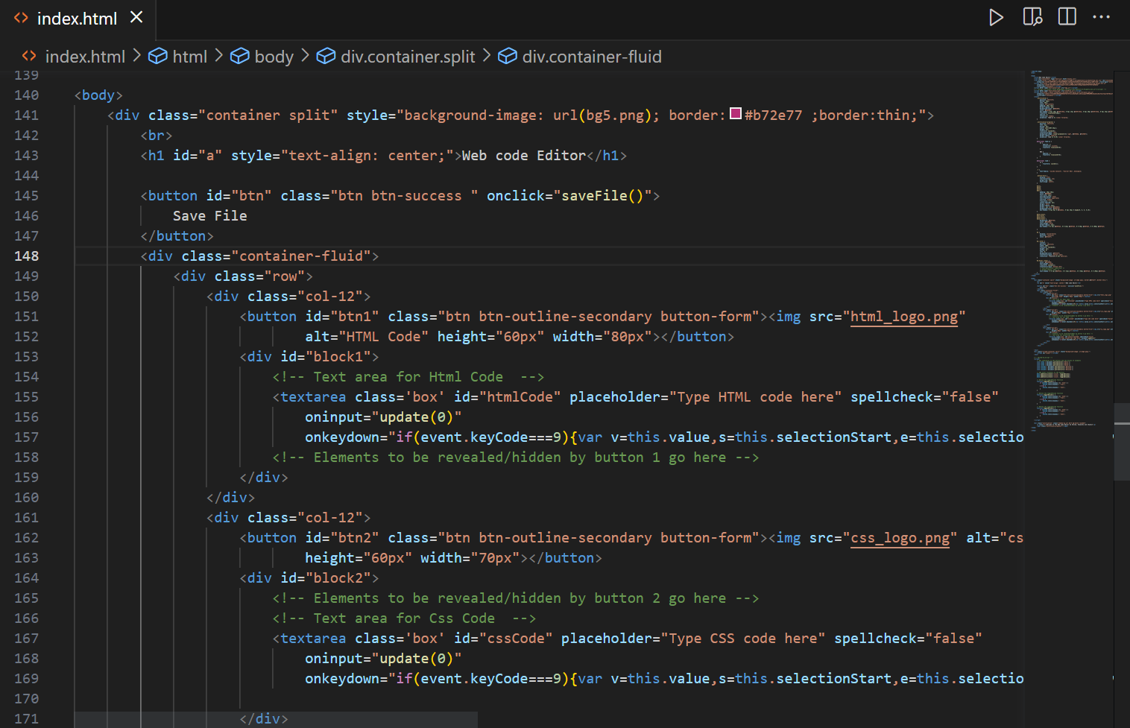

**Div:**

The <div> tag defines a division or a section in an HTML document.

The <div> tag is used as a container for HTML elements - which is then styled with CSS or manipulated with JavaScript.

The <div> tag is easily styled by using the class or id attribute.

Any sort of content can be put inside the <div> tag!

**Button:**

The <button> tag defines a clickable button.

Inside a <button> element you can put text (and tags like <i>, <b>, <strong>, <br>, <img>, etc.). That is not possible with a button created with the [<input>](https://www.w3schools.com/tags/tag_input.asp) element!

**Textarea:**

The <textarea> tag defines a multi-line text input control.

The <textarea> element is often used in a form, to collect user inputs like comments or reviews.

A text area can hold an unlimited number of characters, and the text renders in a fixed-width font (usually Courier).

The size of a text area is specified by the cols and rows attributes (or with CSS).

The name attribute is needed to reference the form data after the form is submitted (if you omit the name attribute, no data from the text area will be submitted).

The id attribute is needed to associate the text area with a label.

**8.CSS used in Web Code Editor**

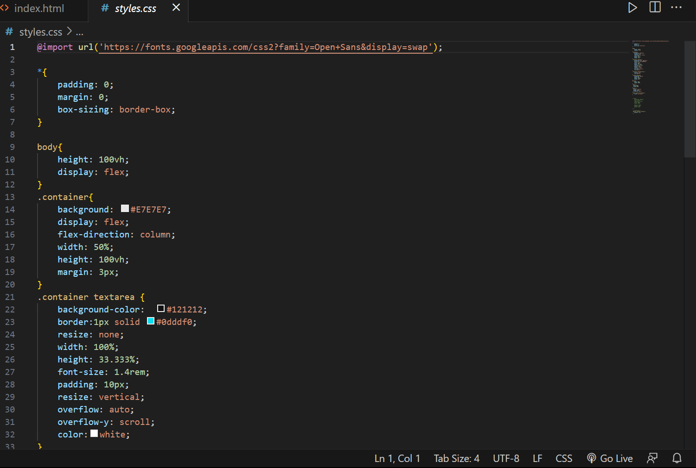

**.Class Selector:**

The *.class* selector selects elements with a specific class attribute.

To select elements with a specific class, write a period (.) character, followed by the name of the class.

You can also specify that only specific HTML elements should be affected by a class. To do this, start with the element name, then write the period (.) character, followed by the name of the class.

9.**Java Script used in Web Code Editor:**

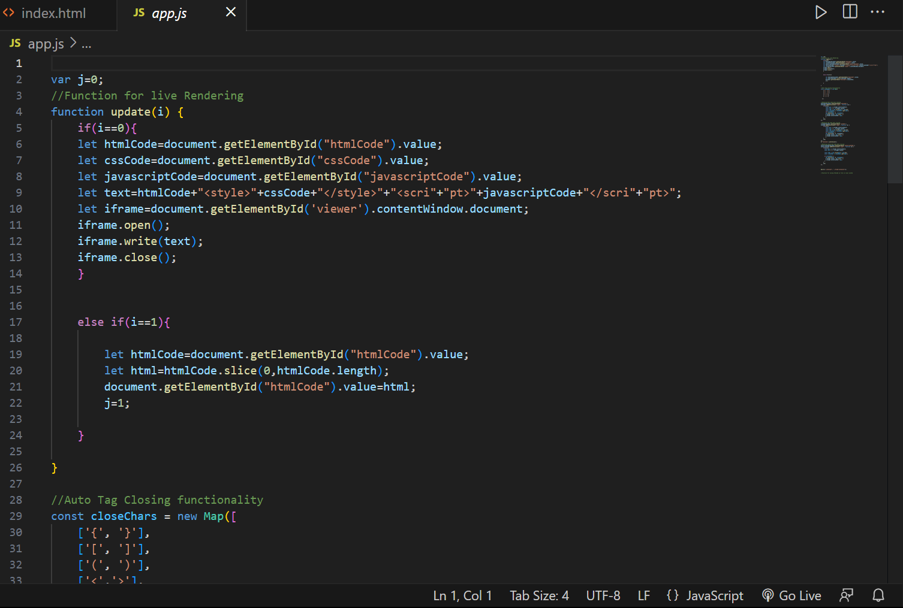

**Functions:**

A JavaScript function is defined with the function keyword, followed by a **name**, followed by parentheses **()**.

Function names can contain letters, digits, underscores, and dollar signs (same rules as variables).

The parentheses may include parameter names separated by commas:  
**(parameter1, parameter2, ...)**

The code to be executed, by the function, is placed inside curly brackets: **{}**

**10.Real Time Example**

**HTML Implementation**

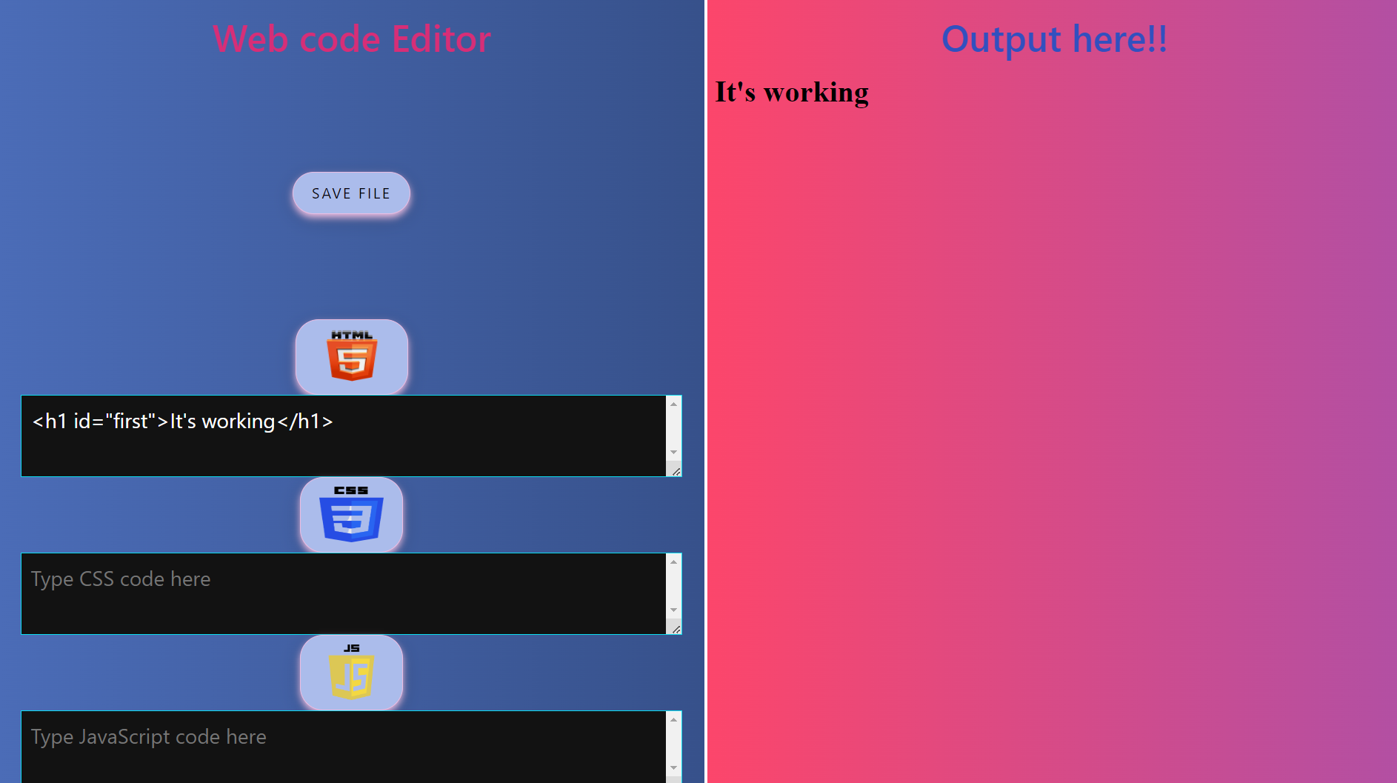

**CSS Implementation**

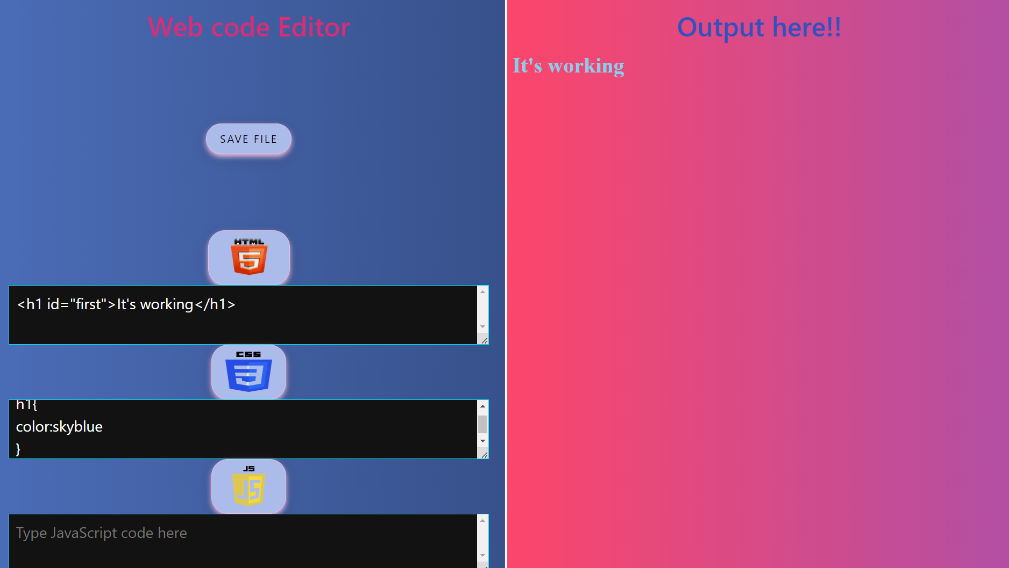

**Java Script Implementation**

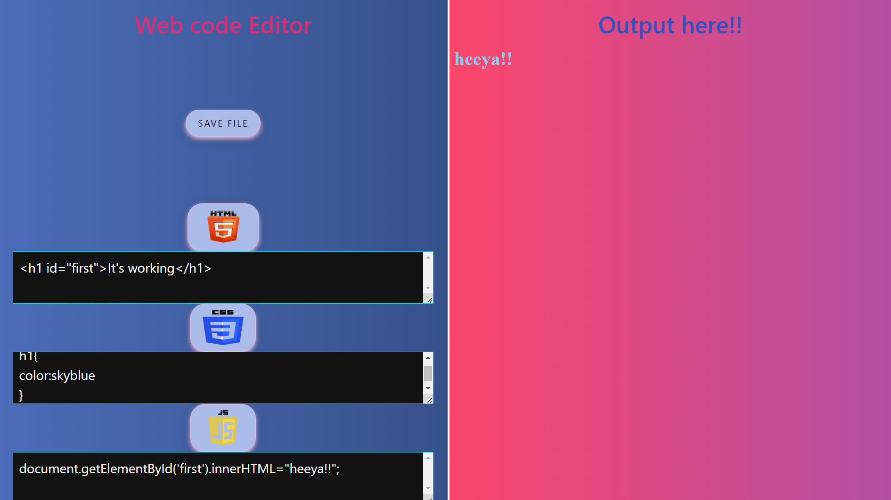

**11.Conclusion**

* 1. **Project Summary**

A summary of the project, including its objectives, achievements, and challenges faced, is provided.

* 1. **Achievements**

The key achievements of the project, such as successful implementation of the code editor with desired features, are highlighted.

* 1. **Lessons Learned**

The lessons learned throughout the project, including technical, managerial, and user-oriented insights, are discussed to improve future endeavors.

* 1. **Future Enhancements**

The potential future enhancements for the code editor, based on user feedback and emerging technologies, are suggested to further improve its functionality.

**12.References**

A list of references, including books, research papers, online resources, and software documentation, used during the project is included for further reading and verification.

Note: The page count may vary depending on the depth of information provided in each section. However, it is important to focus on providing concise and relevant information to ensure a comprehensive yet concise project report.

**References:**

Our Internal and External Trainer

**Website:**

<https://stackoverflow.com/>

https://www.geeksforgeeks.org/